THIAGARAJAR COLLEGE OF ENGINEERING, MADURAI-15.

(A Govt. Aided, ISO 9001:2008 Certified, Autonomous Institution Affiliated to Anna University)

**Contact Address: C/o The Placement officer, Thiagarajar College of Engineering, Madurai – 625015 Telephone : +91+452+2482240/1/2 email :** [**placement@tce.edu**](mailto:placement@tce.edu)

**Fax : +91+452+2483427 Website :** [**www.tce.edu**](http://www.tce.edu/)



# RESUME Name : HARI GOKUL PRASAD K P

**Reg No. : 21C123**

# Degree : B.E. (Computer Science Engineering)

**CAREER OBJECTIVE**

# To work in a collaborative environment where I can constantly update myself and

# positively contribute to the growth of the organization.

# ACADEMIC RECORD

| **COURSE / CLASS** | **NAME OF THE INSTITUTION** | **BOARD OF STUDY** | **YEAR OF PASSING** | **CGPA / MARKS %** |
| --- | --- | --- | --- | --- |
| **B.E (CSE)** | Thiagarajar College of Engineering, Madurai. | Anna University, Chennai | 2025 | 8.24* |
| **DIPLAMO** | Tamilnadu Government Polytechnic College, Madurai. | Autonomous | 2022 | 98.1 |
| **XII** | Thiagarajar Model Higher Secondary School, Madurai. | State Board | 2020 | 68.6 |
| **X** | Thiagarajar Model Higher Secondary School, Madurai. | State Board | 2018 | 84.8 |

* CGPA (out of 10) up to V semester

# AREAS OF INTEREST

* + Object Oriented Programming (in Java)

Web Development

# TECHNICAL SKILLS

* + Programming Languages : C,Java,Basics of Python,Mysql
  + Web Technologies : CSS, HTML

# PERSONAL SKILLS

* + Willingness to Learn
  + Team Spirit
  + Perseverance





**OBJECTIVE : I** successfully contributed to the development of the 'e-bus enquiry' website, which enables users to efficiently track real-time bus details and locations. My role included frontends like HTML,CSS and Data collection demonstrating my ability to deliver valuable solutions in web development.

**PLATFORM :** VS Code, Xampp

**LANGUAGES :** HTML, CSS, PHP, MYSQL



**TITLE : EXAM HALL ALLOCATION (In Process)**

**OBJECTIVE :** To develop an Android application which helps students and also for examiners to know their allocated exam hall during exam period.

**PLATFORM :** Android Studio

**LANGUAGE :** Java



* + - Earned **2 stars** (Bronze Badge) for **Python** in HackerRank.



* + - Recently participated in ‘Smart India Hackathon’.

# PERSONAL DETAILS

# CONTACT ADDRESS PERMANENT ADDRESS

C/O The Placement Officer, S/O Prakash K S,

Thiagarajar College of Engineering, 152, South Perumal Maistry Street,

Thirupparankundram, South gate,

Madurai - 625015. Madurai - 625001.

Email: [placement@tce.edu](mailto:placement@tce.edu) Email: gokulaswin2005mdu@gmail.com

Telephone: +91 452 2482240 Mobile: +91 93614 32552

**DATE OF BIRTH:** 18.01.2003

**AGE:** 20

**SEX:** Male

**FATHER’S NAME:**

**MOTHER TONGUE:** Sourashtra

**LANGUAGES KNOWN:**

**Read :** Tamil, English **Write :** Tamil, English **Speak :** Tamil, English

I, **Hari Gokul Prasad K P**,do hereby confirm that the information given above is true to the best of my knowledge and belief.

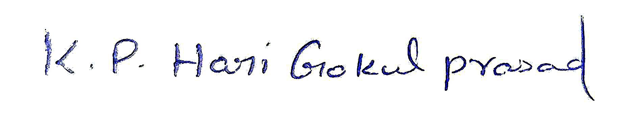

**Place:** Madurai

**Date:** 23.09.2023 **Signature**